Guidance on how to register for the new service

Welcome to the new Community Forums service.
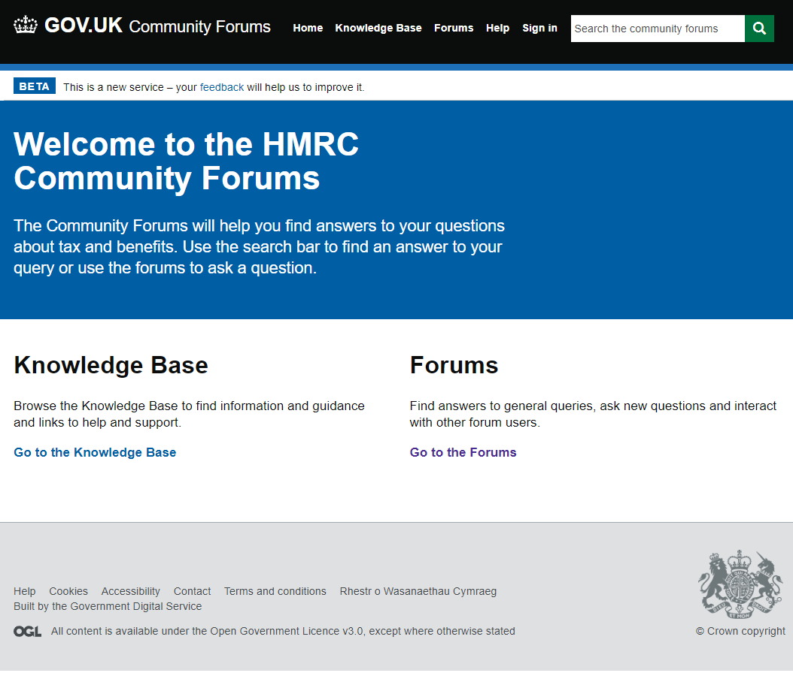
New Forum registration screens
Go to ‘Sign In’
Then click on the ‘Register’ tab Provide the details requested.
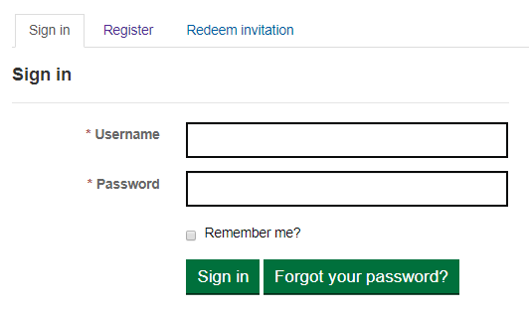
Please provide the details requested
Please note: your password must contain characters from at least three of the following: uppercase, lowercase, numerals or special characters..
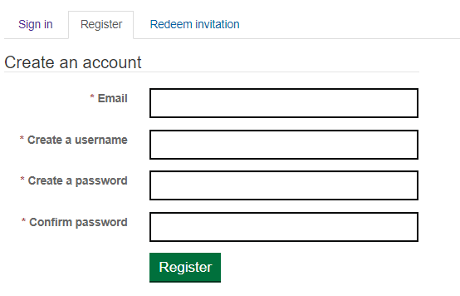
Click ‘Register’ you will be presented with the Terms and Conditions screen.
Read the Terms and Conditions and scroll to the bottom
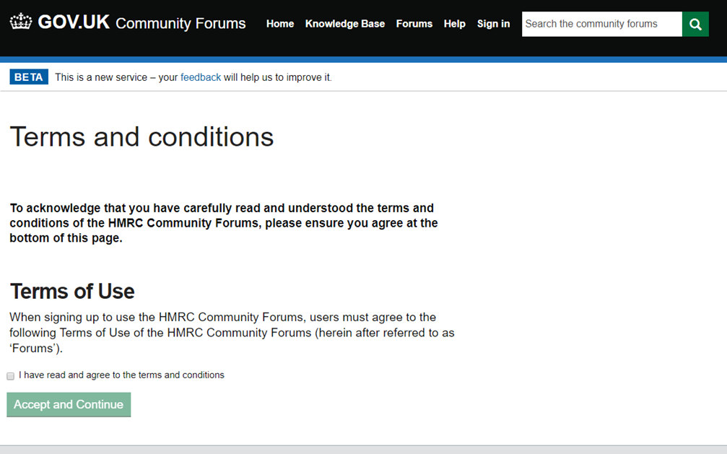
Click “I have read and agree to the terms and conditions”
Click “Accept and Continue”

You will then receive an email confirming you have registered and your username. You do not need to take any action with this e-mail.
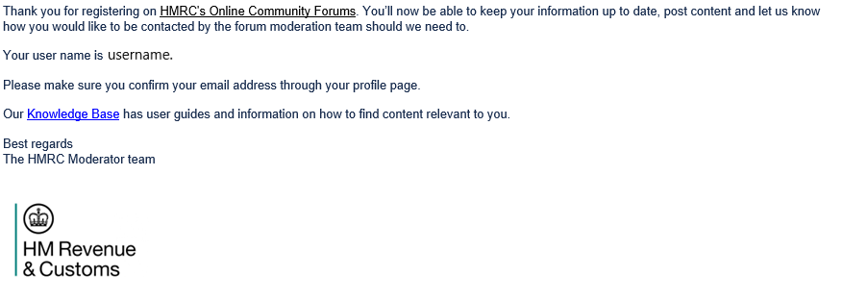
You will be re-directed to your profile page
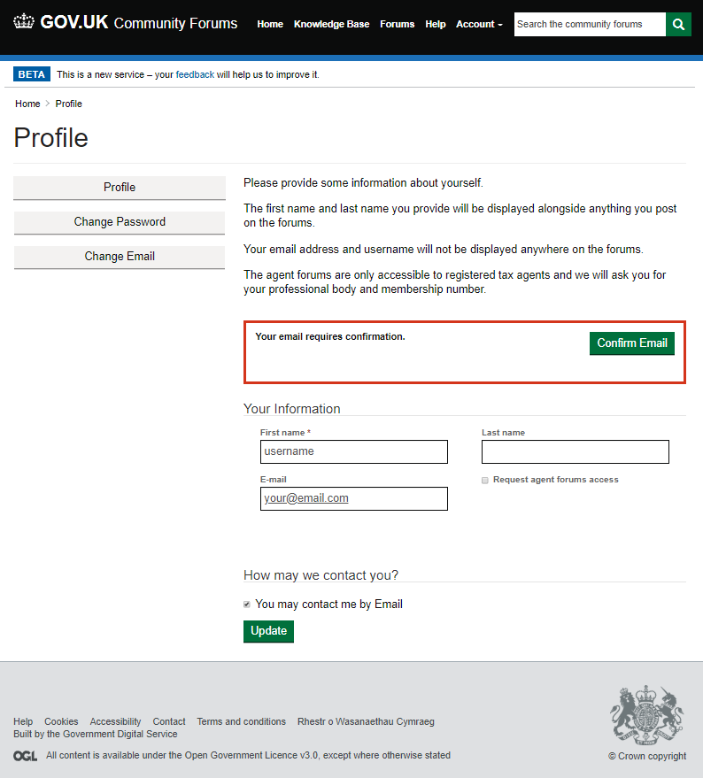
You are now required to confirm your email by clicking the Confirm Email button
Once you have clicked the Confirm Email button you will be taken to the email confirmation page
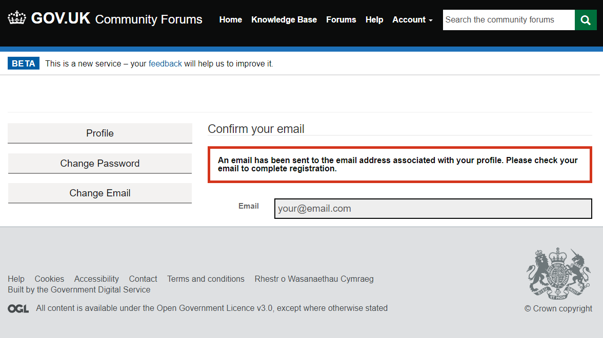

You will receive an email that you will need to click on the ‘Complete Registration’ link or alternatively copy and paste the URL provided into your browser.

You will be returned to the Forum confirmed email address page (below).
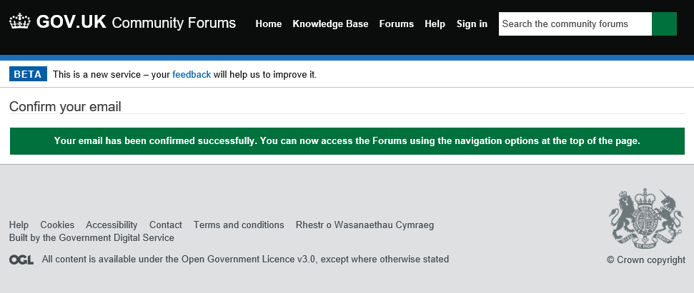
Now Sign In
You will now be taken to your Profile page (from ‘Account’ drop down menu)
